hate as nooff

alpha=2

1 run......

Downloading: 100%

445M/445M [00:14<00:00, 32.9MB/s]

training 1 epoch...

17.40019416809082 seconds used......

1 training finished! average train loss: 2.152463504246303

total clf loss: 56.13549607992172 total adv loss: 32.201230466365814

evaluating...

Confusion matrix, without normalization

[[ 54 19 23]

[ 64 191 100]

[ 48 116 555]]

Normalized confusion matrix

[[0.5625 0.19791667 0.23958333]

[0.18028169 0.53802817 0.28169014]

[0.06675939 0.16133519 0.77190542]]

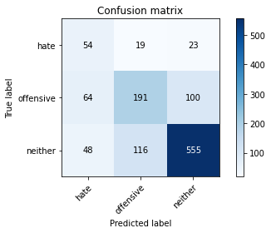

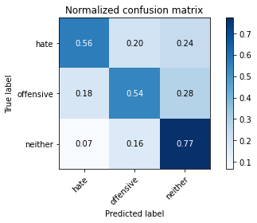

precision recall f1-score support

hate 0.33 0.56 0.41 96

offensive 0.59 0.54 0.56 355

neither 0.82 0.77 0.79 719

accuracy 0.68 1170

macro avg 0.58 0.62 0.59 1170

weighted avg 0.71 0.68 0.69 1170

average eval_loss: 0.7564279699729661, accuracy: 0.6837606837606838

training 2 epoch...

16.67819333076477 seconds used......

2 training finished! average train loss: 1.681937494448253

total clf loss: 41.4411917924881 total adv loss: 26.37365373969078

evaluating...

Confusion matrix, without normalization

[[ 85 10 1]

[115 213 27]

[132 141 446]]

Normalized confusion matrix

[[0.88541667 0.10416667 0.01041667]

[0.32394366 0.6 0.07605634]

[0.18358832 0.1961057 0.62030598]]

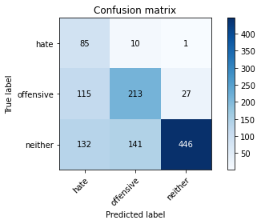

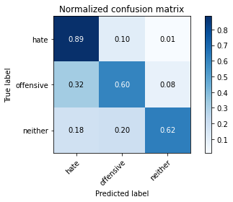

precision recall f1-score support

hate 0.26 0.89 0.40 96

offensive 0.59 0.60 0.59 355

neither 0.94 0.62 0.75 719

accuracy 0.64 1170

macro avg 0.59 0.70 0.58 1170

weighted avg 0.78 0.64 0.67 1170

average eval_loss: 0.8448189335354304, accuracy: 0.6358974358974359

training 3 epoch...

16.668655157089233 seconds used......

3 training finished! average train loss: 1.1157385903809751

total clf loss: 27.17232221364975 total adv loss: 17.65451943129301

evaluating...

Confusion matrix, without normalization

[[ 43 36 17]

[ 20 273 62]

[ 38 149 532]]

Normalized confusion matrix

[[0.44791667 0.375 0.17708333]

[0.05633803 0.76901408 0.17464789]

[0.05285118 0.20723227 0.73991655]]

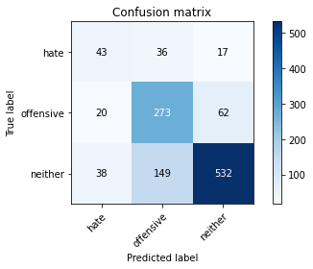

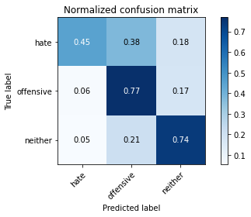

precision recall f1-score support

hate 0.43 0.45 0.44 96

offensive 0.60 0.77 0.67 355

neither 0.87 0.74 0.80 719

accuracy 0.72 1170

macro avg 0.63 0.65 0.64 1170

weighted avg 0.75 0.72 0.73 1170

average eval_loss: 0.6227377723839324, accuracy: 0.7247863247863248

training 4 epoch...

16.538134813308716 seconds used......

4 training finished! average train loss: 0.5886448539261308

total clf loss: 15.43484053015709 total adv loss: 8.764635719824582

evaluating...

Confusion matrix, without normalization

[[ 87 7 2]

[103 220 32]

[118 113 488]]

Normalized confusion matrix

[[0.90625 0.07291667 0.02083333]

[0.29014085 0.61971831 0.09014085]

[0.16411683 0.15716273 0.67872045]]

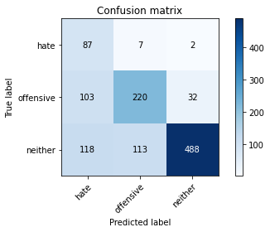

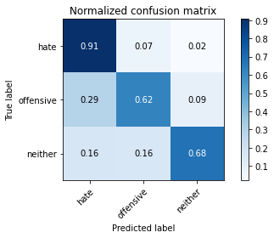

precision recall f1-score support

hate 0.28 0.91 0.43 96

offensive 0.65 0.62 0.63 355

neither 0.93 0.68 0.79 719

accuracy 0.68 1170

macro avg 0.62 0.73 0.62 1170

weighted avg 0.79 0.68 0.71 1170

average eval_loss: 0.8757719660209398, accuracy: 0.6794871794871795

training 5 epoch...

16.68723177909851 seconds used......

5 training finished! average train loss: 0.30146889787699493

total clf loss: 8.581148318946362 total adv loss: 4.1505549976136535

evaluating...

Confusion matrix, without normalization

[[ 66 21 9]

[ 47 250 58]

[ 49 125 545]]

Normalized confusion matrix

[[0.6875 0.21875 0.09375 ]

[0.13239437 0.70422535 0.16338028]

[0.06815021 0.17385257 0.75799722]]

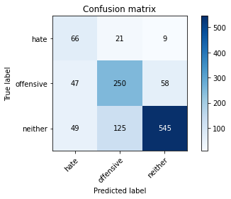

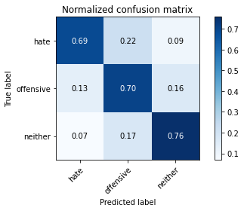

precision recall f1-score support

hate 0.41 0.69 0.51 96

offensive 0.63 0.70 0.67 355

neither 0.89 0.76 0.82 719

accuracy 0.74 1170

macro avg 0.64 0.72 0.67 1170

weighted avg 0.77 0.74 0.75 1170

average eval_loss: 0.7695973732713925, accuracy: 0.735897435897436

training 6 epoch...

16.647736072540283 seconds used......

6 training finished! average train loss: 0.10077996818082673

total clf loss: 3.622956628911197 total adv loss: 1.0103607829660177

evaluating...

Confusion matrix, without normalization

[[ 85 8 3]

[ 99 200 56]

[ 99 103 517]]

Normalized confusion matrix

[[0.88541667 0.08333333 0.03125 ]

[0.27887324 0.56338028 0.15774648]

[0.13769124 0.14325452 0.71905424]]

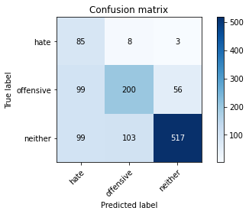

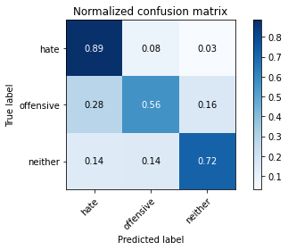

precision recall f1-score support

hate 0.30 0.89 0.45 96

offensive 0.64 0.56 0.60 355

neither 0.90 0.72 0.80 719

accuracy 0.69 1170

macro avg 0.61 0.72 0.62 1170

weighted avg 0.77 0.69 0.71 1170

average eval_loss: 1.0708117323406672, accuracy: 0.6854700854700855

training 7 epoch...

16.59243130683899 seconds used......

7 training finished! average train loss: 0.07479078459021236

total clf loss: 2.2962854499928653 total adv loss: 0.9459992460615467

evaluating...

Confusion matrix, without normalization

[[ 72 17 7]

[ 44 260 51]

[ 53 162 504]]

Normalized confusion matrix

[[0.75 0.17708333 0.07291667]

[0.12394366 0.73239437 0.14366197]

[0.07371349 0.22531293 0.70097357]]

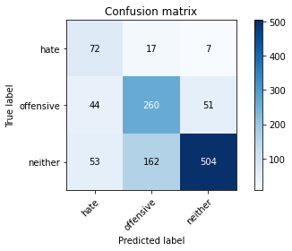

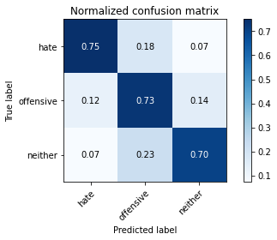

precision recall f1-score support

hate 0.43 0.75 0.54 96

offensive 0.59 0.73 0.65 355

neither 0.90 0.70 0.79 719

accuracy 0.71 1170

macro avg 0.64 0.73 0.66 1170

weighted avg 0.77 0.71 0.73 1170

average eval_loss: 0.9769820267871275, accuracy: 0.7145299145299145

training 8 epoch...

16.629506826400757 seconds used......

8 training finished! average train loss: 0.07496767171791621

total clf loss: 1.9965812896844 total adv loss: 1.100804182671709

evaluating...

Confusion matrix, without normalization

[[ 86 6 4]

[ 94 218 43]

[107 108 504]]

Normalized confusion matrix

[[0.89583333 0.0625 0.04166667]

[0.26478873 0.61408451 0.12112676]

[0.1488178 0.15020862 0.70097357]]

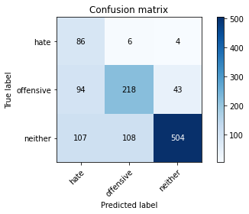

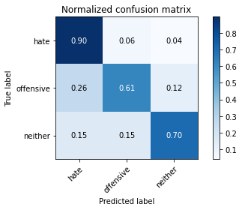

precision recall f1-score support

hate 0.30 0.90 0.45 96

offensive 0.66 0.61 0.63 355

neither 0.91 0.70 0.79 719

accuracy 0.69 1170

macro avg 0.62 0.74 0.63 1170

weighted avg 0.79 0.69 0.72 1170

average eval_loss: 1.24228571986748, accuracy: 0.6905982905982906

training 9 epoch...

16.62396216392517 seconds used......

9 training finished! average train loss: 0.023426669697593234

total clf loss: 0.8235598499886692 total adv loss: 0.2441668266292254

evaluating...

Confusion matrix, without normalization

[[ 84 6 6]

[ 88 212 55]

[ 77 106 536]]

Normalized confusion matrix

[[0.875 0.0625 0.0625 ]

[0.24788732 0.5971831 0.15492958]

[0.10709318 0.14742698 0.74547983]]

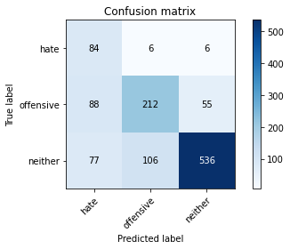

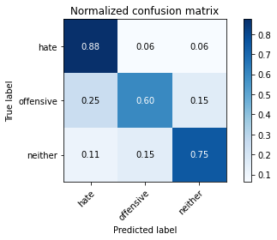

precision recall f1-score support

hate 0.34 0.88 0.49 96

offensive 0.65 0.60 0.62 355

neither 0.90 0.75 0.81 719

accuracy 0.71 1170

macro avg 0.63 0.74 0.64 1170

weighted avg 0.78 0.71 0.73 1170

average eval_loss: 1.2132169061293037, accuracy: 0.7111111111111111

training 10 epoch...

16.55335569381714 seconds used......

10 training finished! average train loss: 0.017999991643591784

total clf loss: 0.5757191767916083 total adv loss: 0.21614018014224712

evaluating...

Confusion matrix, without normalization

[[ 79 12 5]

[ 55 258 42]

[ 67 144 508]]

Normalized confusion matrix

[[0.82291667 0.125 0.05208333]

[0.15492958 0.72676056 0.11830986]

[0.09318498 0.20027816 0.70653686]]

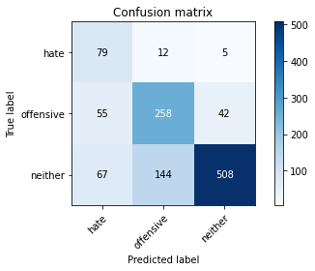

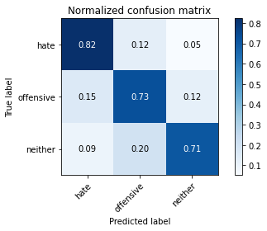

precision recall f1-score support

hate 0.39 0.82 0.53 96

offensive 0.62 0.73 0.67 355

neither 0.92 0.71 0.80 719

accuracy 0.72 1170

macro avg 0.64 0.75 0.67 1170

weighted avg 0.78 0.72 0.74 1170

average eval_loss: 1.1866970173383162, accuracy: 0.7222222222222222

2 run......

training 1 epoch...

16.546565532684326 seconds used......

1 training finished! average train loss: 2.1944805660418103

total clf loss: 56.70132577419281 total adv loss: 33.094793021678925

evaluating...

Confusion matrix, without normalization

[[ 40 27 29]

[ 42 225 88]

[ 35 128 556]]

Normalized confusion matrix

[[0.41666667 0.28125 0.30208333]

[0.11830986 0.63380282 0.24788732]

[0.04867872 0.17802503 0.77329624]]

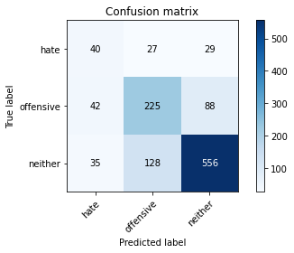

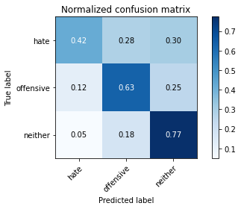

precision recall f1-score support

hate 0.34 0.42 0.38 96

offensive 0.59 0.63 0.61 355

neither 0.83 0.77 0.80 719

accuracy 0.70 1170

macro avg 0.59 0.61 0.60 1170

weighted avg 0.72 0.70 0.71 1170

average eval_loss: 0.7179330637899496, accuracy: 0.7017094017094017

training 2 epoch...

16.58157968521118 seconds used......

2 training finished! average train loss: 1.597095517175538

total clf loss: 37.652089327573776 total adv loss: 25.89262966811657

evaluating...

Confusion matrix, without normalization

[[ 52 35 9]

[ 29 266 60]

[ 51 165 503]]

Normalized confusion matrix

[[0.54166667 0.36458333 0.09375 ]

[0.08169014 0.74929577 0.16901408]

[0.07093185 0.2294854 0.69958275]]

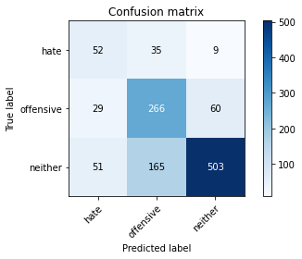

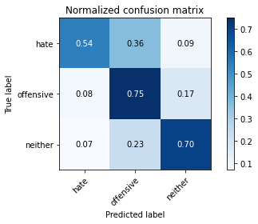

precision recall f1-score support

hate 0.39 0.54 0.46 96

offensive 0.57 0.75 0.65 355

neither 0.88 0.70 0.78 719

accuracy 0.70 1170

macro avg 0.61 0.66 0.63 1170

weighted avg 0.75 0.70 0.71 1170

average eval_loss: 0.7117365947214224, accuracy: 0.7017094017094017

training 3 epoch...

16.545673370361328 seconds used......

3 training finished! average train loss: 0.8854740408382246

total clf loss: 20.484894573688507 total adv loss: 14.550825793296099

evaluating...

Confusion matrix, without normalization

[[ 41 45 10]

[ 16 295 44]

[ 29 210 480]]

Normalized confusion matrix

[[0.42708333 0.46875 0.10416667]

[0.04507042 0.83098592 0.12394366]

[0.0403338 0.29207232 0.66759388]]

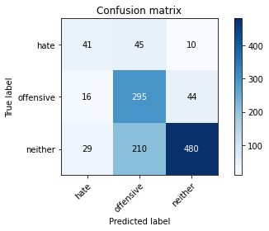

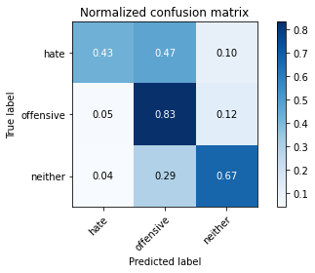

precision recall f1-score support

hate 0.48 0.43 0.45 96

offensive 0.54 0.83 0.65 355

neither 0.90 0.67 0.77 719

accuracy 0.70 1170

macro avg 0.64 0.64 0.62 1170

weighted avg 0.75 0.70 0.71 1170

average eval_loss: 0.7738005286556179, accuracy: 0.6974358974358974

training 4 epoch...

16.578879356384277 seconds used......

4 training finished! average train loss: 0.42004383927477257

total clf loss: 10.115853250026703 total adv loss: 6.703300843480974

evaluating...

Confusion matrix, without normalization

[[ 48 42 6]

[ 34 284 37]

[ 50 187 482]]

Normalized confusion matrix

[[0.5 0.4375 0.0625 ]

[0.09577465 0.8 0.10422535]

[0.06954103 0.26008345 0.67037552]]

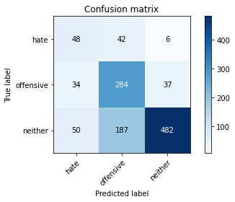

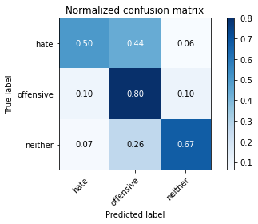

precision recall f1-score support

hate 0.36 0.50 0.42 96

offensive 0.55 0.80 0.65 355

neither 0.92 0.67 0.77 719

accuracy 0.70 1170

macro avg 0.61 0.66 0.62 1170

weighted avg 0.76 0.70 0.71 1170

average eval_loss: 0.8856319623478388, accuracy: 0.6957264957264957

training 5 epoch...

16.64948844909668 seconds used......

5 training finished! average train loss: 0.167874072412295

total clf loss: 4.61469934694469 total adv loss: 2.3931243454571813

evaluating...

Confusion matrix, without normalization

[[ 78 10 8]

[ 67 215 73]

[ 56 111 552]]

Normalized confusion matrix

[[0.8125 0.10416667 0.08333333]

[0.18873239 0.6056338 0.2056338 ]

[0.07788595 0.15438108 0.76773296]]

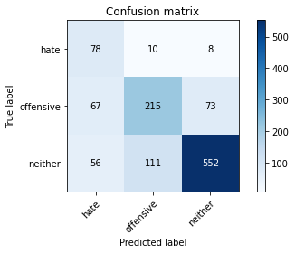

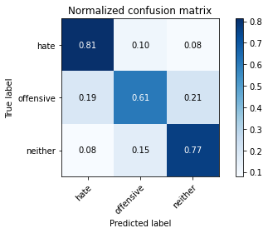

precision recall f1-score support

hate 0.39 0.81 0.53 96

offensive 0.64 0.61 0.62 355

neither 0.87 0.77 0.82 719

accuracy 0.72 1170

macro avg 0.63 0.73 0.65 1170

weighted avg 0.76 0.72 0.73 1170

average eval_loss: 0.9038550740076323, accuracy: 0.7222222222222222

training 6 epoch...

16.5306134223938 seconds used......

6 training finished! average train loss: 0.12010898080188781

total clf loss: 2.733825547620654 total adv loss: 1.9961386850336567

evaluating...

Confusion matrix, without normalization

[[ 81 4 11]

[ 90 181 84]

[ 81 63 575]]

Normalized confusion matrix

[[0.84375 0.04166667 0.11458333]

[0.25352113 0.50985915 0.23661972]

[0.11265647 0.0876217 0.79972184]]

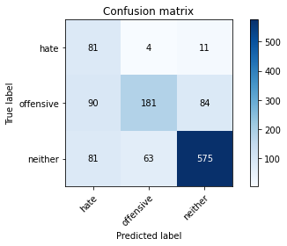

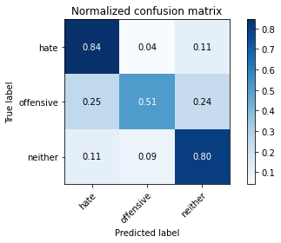

precision recall f1-score support

hate 0.32 0.84 0.47 96

offensive 0.73 0.51 0.60 355

neither 0.86 0.80 0.83 719

accuracy 0.72 1170

macro avg 0.64 0.72 0.63 1170

weighted avg 0.78 0.72 0.73 1170

average eval_loss: 1.0036881793353518, accuracy: 0.7153846153846154

training 7 epoch...

16.524185180664062 seconds used......

7 training finished! average train loss: 0.07637762735664312

total clf loss: 1.7882879429962486 total adv loss: 1.2444295885798056

evaluating...

Confusion matrix, without normalization

[[ 80 8 8]

[ 84 222 49]

[ 84 113 522]]

Normalized confusion matrix

[[0.83333333 0.08333333 0.08333333]

[0.23661972 0.62535211 0.13802817]

[0.11682893 0.15716273 0.72600834]]

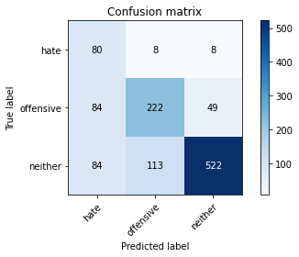

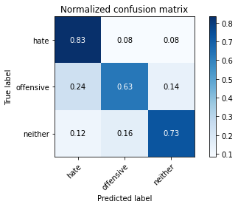

precision recall f1-score support

hate 0.32 0.83 0.47 96

offensive 0.65 0.63 0.64 355

neither 0.90 0.73 0.80 719

accuracy 0.70 1170

macro avg 0.62 0.73 0.64 1170

weighted avg 0.78 0.70 0.73 1170

average eval_loss: 1.1681854272797956, accuracy: 0.7042735042735043

training 8 epoch...

16.58069086074829 seconds used......

8 training finished! average train loss: 0.03316202935197258

total clf loss: 0.9280121773481369 total adv loss: 0.4645307486061938

evaluating...

Confusion matrix, without normalization

[[ 74 10 12]

[ 50 235 70]

[ 39 101 579]]

Normalized confusion matrix

[[0.77083333 0.10416667 0.125 ]

[0.14084507 0.66197183 0.1971831 ]

[0.054242 0.14047288 0.80528512]]

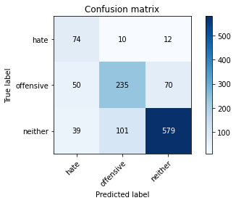

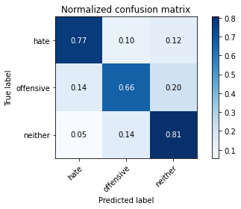

precision recall f1-score support

hate 0.45 0.77 0.57 96

offensive 0.68 0.66 0.67 355

neither 0.88 0.81 0.84 719

accuracy 0.76 1170

macro avg 0.67 0.75 0.69 1170

weighted avg 0.78 0.76 0.77 1170

average eval_loss: 0.9995249247146865, accuracy: 0.7589743589743589

training 9 epoch...

16.556517362594604 seconds used......

9 training finished! average train loss: 0.026636459864676

total clf loss: 0.819040842121467 total adv loss: 0.3363004569837358

evaluating...

Confusion matrix, without normalization

[[ 84 5 7]

[ 85 218 52]

[ 85 104 530]]

Normalized confusion matrix

[[0.875 0.05208333 0.07291667]

[0.23943662 0.61408451 0.14647887]

[0.11821975 0.14464534 0.73713491]]

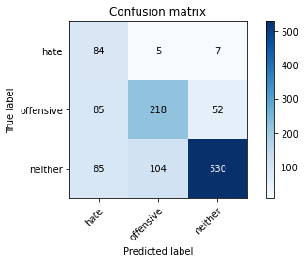

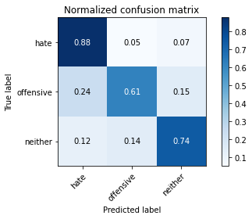

precision recall f1-score support

hate 0.33 0.88 0.48 96

offensive 0.67 0.61 0.64 355

neither 0.90 0.74 0.81 719

accuracy 0.71 1170

macro avg 0.63 0.74 0.64 1170

weighted avg 0.78 0.71 0.73 1170

average eval_loss: 1.2731262399988659, accuracy: 0.7111111111111111

training 10 epoch...

16.53447198867798 seconds used......

10 training finished! average train loss: 0.012822106339236987

total clf loss: 0.4489088786067441 total adv loss: 0.1345645458859508

evaluating...

Confusion matrix, without normalization

[[ 82 3 11]

[ 82 199 74]

[ 73 62 584]]

Normalized confusion matrix

[[0.85416667 0.03125 0.11458333]

[0.23098592 0.56056338 0.2084507 ]

[0.1015299 0.08623088 0.81223922]]

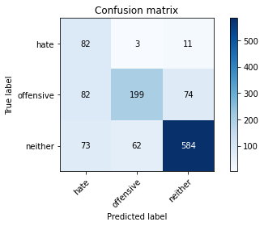

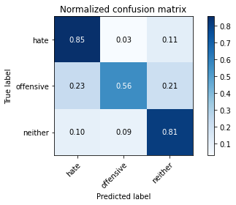

precision recall f1-score support

hate 0.35 0.85 0.49 96

offensive 0.75 0.56 0.64 355

neither 0.87 0.81 0.84 719

accuracy 0.74 1170

macro avg 0.66 0.74 0.66 1170

weighted avg 0.79 0.74 0.75 1170

average eval_loss: 1.182510746232534, accuracy: 0.7393162393162394

3 run......

training 1 epoch...

16.51707911491394 seconds used......

1 training finished! average train loss: 2.143760342683111

total clf loss: 55.18017715215683 total adv loss: 32.435200959444046

evaluating...

Confusion matrix, without normalization

[[ 66 24 6]

[ 61 242 52]

[ 86 150 483]]

Normalized confusion matrix

[[0.6875 0.25 0.0625 ]

[0.17183099 0.68169014 0.14647887]

[0.11961057 0.20862309 0.67176634]]

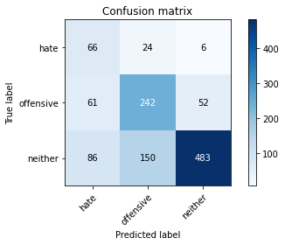

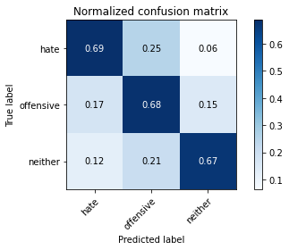

precision recall f1-score support

hate 0.31 0.69 0.43 96

offensive 0.58 0.68 0.63 355

neither 0.89 0.67 0.77 719

accuracy 0.68 1170

macro avg 0.59 0.68 0.61 1170

weighted avg 0.75 0.68 0.70 1170

average eval_loss: 0.7931037969508413, accuracy: 0.6760683760683761

training 2 epoch...

16.485002517700195 seconds used......

2 training finished! average train loss: 1.4911187759467535

total clf loss: 35.69304230809212 total adv loss: 23.90480461716652

evaluating...

Confusion matrix, without normalization

[[ 84 3 9]

[119 136 100]

[100 38 581]]

Normalized confusion matrix

[[0.875 0.03125 0.09375 ]

[0.33521127 0.38309859 0.28169014]

[0.13908206 0.05285118 0.80806676]]

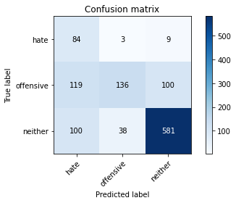

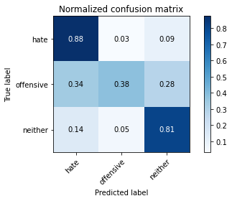

precision recall f1-score support

hate 0.28 0.88 0.42 96

offensive 0.77 0.38 0.51 355

neither 0.84 0.81 0.82 719

accuracy 0.68 1170

macro avg 0.63 0.69 0.59 1170

weighted avg 0.77 0.68 0.70 1170

average eval_loss: 0.7413821275961601, accuracy: 0.6846153846153846

training 3 epoch...

16.444536685943604 seconds used......

3 training finished! average train loss: 0.8719387709030083

total clf loss: 21.81513799726963 total adv loss: 13.506716679781675

evaluating...

Confusion matrix, without normalization

[[ 92 3 1]

[106 196 53]

[136 89 494]]

Normalized confusion matrix

[[0.95833333 0.03125 0.01041667]

[0.29859155 0.55211268 0.14929577]

[0.1891516 0.12378303 0.68706537]]

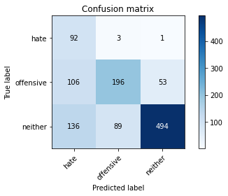

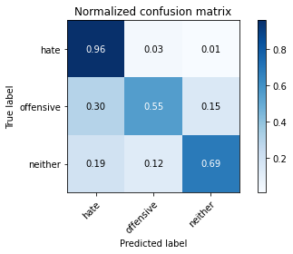

precision recall f1-score support

hate 0.28 0.96 0.43 96

offensive 0.68 0.55 0.61 355

neither 0.90 0.69 0.78 719

accuracy 0.67 1170

macro avg 0.62 0.73 0.61 1170

weighted avg 0.78 0.67 0.70 1170

average eval_loss: 0.8684350095563016, accuracy: 0.6683760683760683

training 4 epoch...

16.523125410079956 seconds used......

4 training finished! average train loss: 0.3240669587893145

total clf loss: 9.267832040786743 total adv loss: 4.43995876586996

evaluating...

Confusion matrix, without normalization

[[ 89 5 2]

[ 91 223 41]

[132 119 468]]

Normalized confusion matrix

[[0.92708333 0.05208333 0.02083333]

[0.25633803 0.62816901 0.11549296]

[0.18358832 0.16550765 0.65090403]]

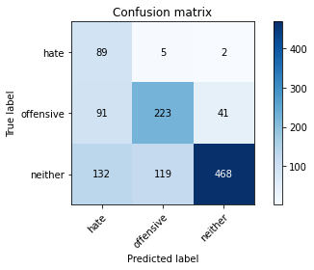

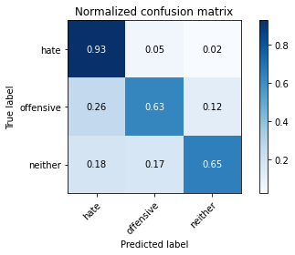

precision recall f1-score support

hate 0.29 0.93 0.44 96

offensive 0.64 0.63 0.64 355

neither 0.92 0.65 0.76 719

accuracy 0.67 1170

macro avg 0.61 0.74 0.61 1170

weighted avg 0.78 0.67 0.70 1170

average eval_loss: 1.0416270471730475, accuracy: 0.6666666666666666

training 5 epoch...

16.492010831832886 seconds used......

5 training finished! average train loss: 0.15412505506537855

total clf loss: 4.789549541659653 total adv loss: 1.9207267694582697

evaluating...

Confusion matrix, without normalization

[[ 75 11 10]

[ 64 232 59]

[ 58 111 550]]

Normalized confusion matrix

[[0.78125 0.11458333 0.10416667]

[0.18028169 0.65352113 0.16619718]

[0.08066759 0.15438108 0.76495132]]

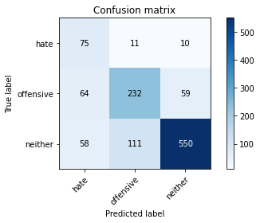

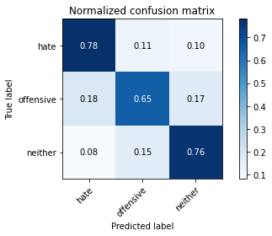

precision recall f1-score support

hate 0.38 0.78 0.51 96

offensive 0.66 0.65 0.65 355

neither 0.89 0.76 0.82 719

accuracy 0.73 1170

macro avg 0.64 0.73 0.66 1170

weighted avg 0.78 0.73 0.75 1170

average eval_loss: 0.9063932115243654, accuracy: 0.7324786324786324

training 6 epoch...

16.452362060546875 seconds used......

6 training finished! average train loss: 0.08907044053609882

total clf loss: 2.4784727967344224 total adv loss: 1.2547359274758492

evaluating...

Confusion matrix, without normalization

[[ 77 7 12]

[ 74 220 61]

[ 69 93 557]]

Normalized confusion matrix

[[0.80208333 0.07291667 0.125 ]

[0.2084507 0.61971831 0.17183099]

[0.09596662 0.12934631 0.77468707]]

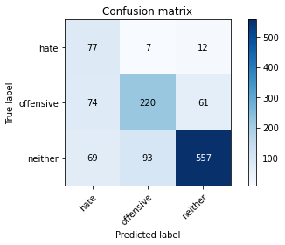

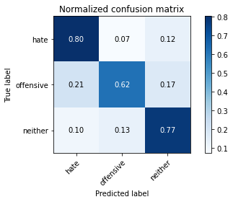

precision recall f1-score support

hate 0.35 0.80 0.49 96

offensive 0.69 0.62 0.65 355

neither 0.88 0.77 0.83 719

accuracy 0.73 1170

macro avg 0.64 0.73 0.65 1170

weighted avg 0.78 0.73 0.75 1170

average eval_loss: 0.9908593956191661, accuracy: 0.7299145299145299

training 7 epoch...

16.581153392791748 seconds used......

7 training finished! average train loss: 0.0320862265195631

total clf loss: 1.0766705421265215 total adv loss: 0.36007908271130873

evaluating...

Confusion matrix, without normalization

[[ 88 4 4]

[108 174 73]

[117 50 552]]

Normalized confusion matrix

[[0.91666667 0.04166667 0.04166667]

[0.30422535 0.49014085 0.2056338 ]

[0.16272601 0.06954103 0.76773296]]

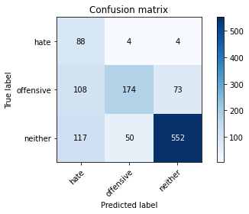

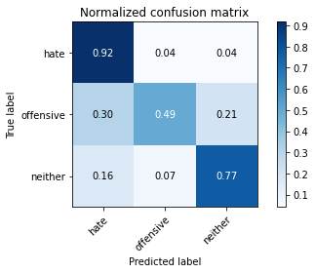

precision recall f1-score support

hate 0.28 0.92 0.43 96

offensive 0.76 0.49 0.60 355

neither 0.88 0.77 0.82 719

accuracy 0.70 1170

macro avg 0.64 0.72 0.62 1170

weighted avg 0.79 0.70 0.72 1170

average eval_loss: 1.2726741039146812, accuracy: 0.6957264957264957

training 8 epoch...

16.59323000907898 seconds used......

8 training finished! average train loss: 0.08825597917062364

total clf loss: 1.6606072287540883 total adv loss: 1.640863779495703

evaluating...

Confusion matrix, without normalization

[[ 76 6 14]

[ 71 191 93]

[ 57 68 594]]

Normalized confusion matrix

[[0.79166667 0.0625 0.14583333]

[0.2 0.53802817 0.26197183]

[0.07927677 0.0945758 0.82614743]]

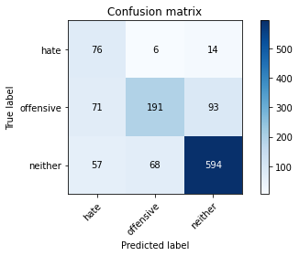

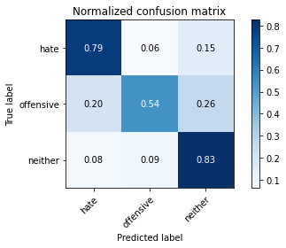

precision recall f1-score support

hate 0.37 0.79 0.51 96

offensive 0.72 0.54 0.62 355

neither 0.85 0.83 0.84 719

accuracy 0.74 1170

macro avg 0.65 0.72 0.65 1170

weighted avg 0.77 0.74 0.74 1170

average eval_loss: 1.0503006747339743, accuracy: 0.735897435897436

training 9 epoch...

16.505090713500977 seconds used......

9 training finished! average train loss: 0.041065421229827086

total clf loss: 1.1119211921468377 total adv loss: 0.5938711997623614

evaluating...

Confusion matrix, without normalization

[[ 82 6 8]

[ 93 200 62]

[ 88 81 550]]

Normalized confusion matrix

[[0.85416667 0.0625 0.08333333]

[0.26197183 0.56338028 0.17464789]

[0.12239221 0.11265647 0.76495132]]

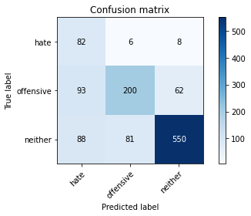

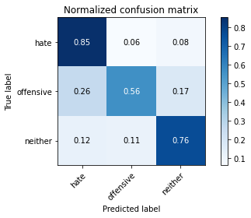

precision recall f1-score support

hate 0.31 0.85 0.46 96

offensive 0.70 0.56 0.62 355

neither 0.89 0.76 0.82 719

accuracy 0.71 1170

macro avg 0.63 0.73 0.63 1170

weighted avg 0.78 0.71 0.73 1170

average eval_loss: 1.2896215308899597, accuracy: 0.7111111111111111

training 10 epoch...

16.61633563041687 seconds used......

10 training finished! average train loss: 0.009080631908935695

total clf loss: 0.3219042487908155 total adv loss: 0.0933055651066752

evaluating...

Confusion matrix, without normalization

[[ 82 6 8]

[ 85 223 47]

[ 90 108 521]]

Normalized confusion matrix

[[0.85416667 0.0625 0.08333333]

[0.23943662 0.62816901 0.13239437]

[0.12517385 0.15020862 0.72461752]]

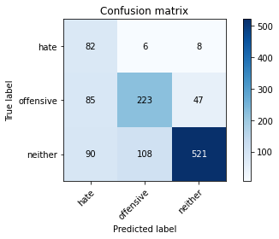

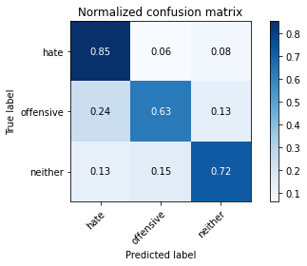

precision recall f1-score support

hate 0.32 0.85 0.46 96

offensive 0.66 0.63 0.64 355

neither 0.90 0.72 0.80 719

accuracy 0.71 1170

macro avg 0.63 0.74 0.64 1170

weighted avg 0.78 0.71 0.73 1170

average eval_loss: 1.3937893692972296, accuracy: 0.705982905982906

4 run......

training 1 epoch...

16.547800302505493 seconds used......

1 training finished! average train loss: 2.2301400857312337

total clf loss: 57.25018119812012 total adv loss: 33.81883180141449

evaluating...

Confusion matrix, without normalization

[[ 33 41 22]

[ 37 248 70]

[ 32 183 504]]

Normalized confusion matrix

[[0.34375 0.42708333 0.22916667]

[0.10422535 0.69859155 0.1971831 ]

[0.04450626 0.25452017 0.70097357]]

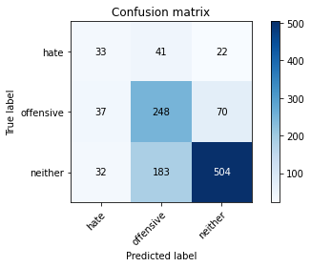

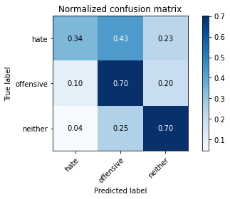

precision recall f1-score support

hate 0.32 0.34 0.33 96

offensive 0.53 0.70 0.60 355

neither 0.85 0.70 0.77 719

accuracy 0.67 1170

macro avg 0.56 0.58 0.57 1170

weighted avg 0.71 0.67 0.68 1170

average eval_loss: 0.7399588691986213, accuracy: 0.6709401709401709

training 2 epoch...

16.529205799102783 seconds used......

2 training finished! average train loss: 1.6421130278280802

total clf loss: 39.289402812719345 total adv loss: 26.33446353673935

evaluating...

Confusion matrix, without normalization

[[ 80 14 2]

[ 97 217 41]

[134 139 446]]

Normalized confusion matrix

[[0.83333333 0.14583333 0.02083333]

[0.27323944 0.61126761 0.11549296]

[0.18636996 0.19332406 0.62030598]]

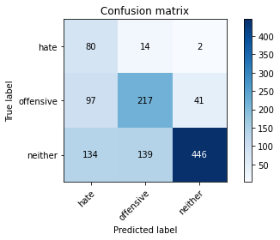

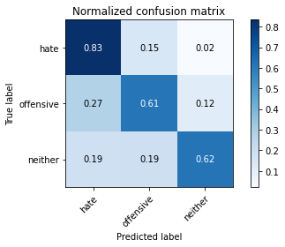

precision recall f1-score support

hate 0.26 0.83 0.39 96

offensive 0.59 0.61 0.60 355

neither 0.91 0.62 0.74 719

accuracy 0.64 1170

macro avg 0.59 0.69 0.58 1170

weighted avg 0.76 0.64 0.67 1170

average eval_loss: 0.8631730281700523, accuracy: 0.635042735042735

training 3 epoch...

16.498607873916626 seconds used......

3 training finished! average train loss: 0.9956435587789331

total clf loss: 24.10843276977539 total adv loss: 15.823803454637527

evaluating...

Confusion matrix, without normalization

[[ 76 16 4]

[ 91 229 35]

[129 146 444]]

Normalized confusion matrix

[[0.79166667 0.16666667 0.04166667]

[0.25633803 0.64507042 0.09859155]

[0.17941586 0.20305981 0.61752434]]

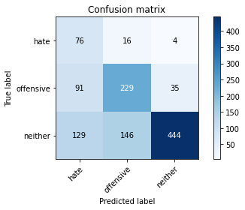

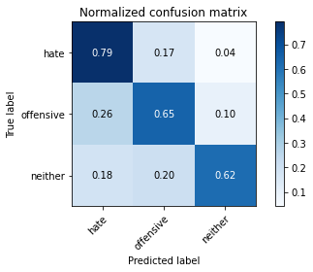

precision recall f1-score support

hate 0.26 0.79 0.39 96

offensive 0.59 0.65 0.61 355

neither 0.92 0.62 0.74 719

accuracy 0.64 1170

macro avg 0.59 0.68 0.58 1170

weighted avg 0.76 0.64 0.67 1170

average eval_loss: 0.9353383451195086, accuracy: 0.6401709401709401

training 4 epoch...

16.49127960205078 seconds used......

4 training finished! average train loss: 0.5530507407550301

total clf loss: 14.273414365947247 total adv loss: 8.348713519051671

evaluating...

Confusion matrix, without normalization

[[ 79 12 5]

[ 87 224 44]

[107 138 474]]

Normalized confusion matrix

[[0.82291667 0.125 0.05208333]

[0.24507042 0.63098592 0.12394366]

[0.1488178 0.19193324 0.65924896]]

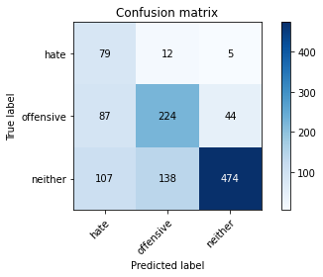

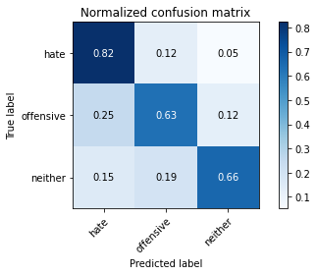

precision recall f1-score support

hate 0.29 0.82 0.43 96

offensive 0.60 0.63 0.61 355

neither 0.91 0.66 0.76 719

accuracy 0.66 1170

macro avg 0.60 0.70 0.60 1170

weighted avg 0.76 0.66 0.69 1170

average eval_loss: 0.9644239605483362, accuracy: 0.6641025641025641

training 5 epoch...

16.433364868164062 seconds used......

5 training finished! average train loss: 0.2362445341423154

total clf loss: 6.818443842232227 total adv loss: 3.205625021888409

evaluating...

Confusion matrix, without normalization

[[ 75 11 10]

[ 80 210 65]

[ 86 101 532]]

Normalized confusion matrix

[[0.78125 0.11458333 0.10416667]

[0.22535211 0.5915493 0.18309859]

[0.11961057 0.14047288 0.73991655]]

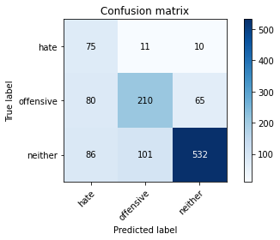

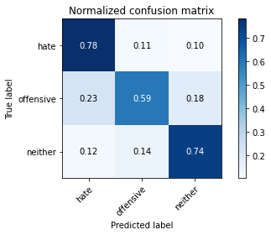

precision recall f1-score support

hate 0.31 0.78 0.45 96

offensive 0.65 0.59 0.62 355

neither 0.88 0.74 0.80 719

accuracy 0.70 1170

macro avg 0.61 0.70 0.62 1170

weighted avg 0.76 0.70 0.72 1170

average eval_loss: 1.0236377109915524, accuracy: 0.6982905982905983

training 6 epoch...

16.49191975593567 seconds used......

6 training finished! average train loss: 0.20621575754401938

total clf loss: 5.115463899448514 total adv loss: 3.216309280367568

evaluating...

Confusion matrix, without normalization

[[ 85 5 6]

[ 96 205 54]

[ 99 97 523]]

Normalized confusion matrix

[[0.88541667 0.05208333 0.0625 ]

[0.27042254 0.57746479 0.15211268]

[0.13769124 0.1349096 0.72739917]]

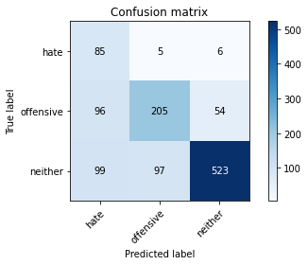

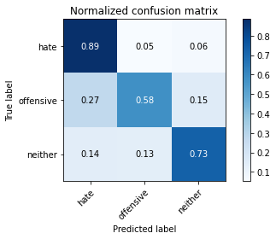

precision recall f1-score support

hate 0.30 0.89 0.45 96

offensive 0.67 0.58 0.62 355

neither 0.90 0.73 0.80 719

accuracy 0.69 1170

macro avg 0.62 0.73 0.62 1170

weighted avg 0.78 0.69 0.72 1170

average eval_loss: 1.2044043434878526, accuracy: 0.6948717948717948

training 7 epoch...

16.485535860061646 seconds used......

7 training finished! average train loss: 0.09301579381073159

total clf loss: 2.799585417844355 total adv loss: 1.2046495124232024

evaluating...

Confusion matrix, without normalization

[[ 81 12 3]

[ 87 231 37]

[116 152 451]]

Normalized confusion matrix

[[0.84375 0.125 0.03125 ]

[0.24507042 0.65070423 0.10422535]

[0.16133519 0.21140473 0.62726008]]

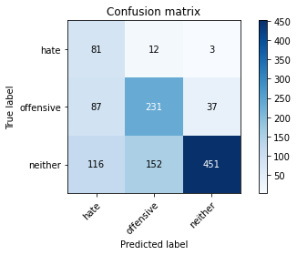

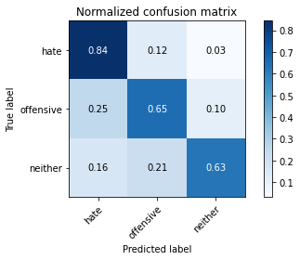

precision recall f1-score support

hate 0.29 0.84 0.43 96

offensive 0.58 0.65 0.62 355

neither 0.92 0.63 0.75 719

accuracy 0.65 1170

macro avg 0.60 0.71 0.60 1170

weighted avg 0.77 0.65 0.68 1170

average eval_loss: 1.4674610667309518, accuracy: 0.6521367521367522

training 8 epoch...

16.453001976013184 seconds used......

8 training finished! average train loss: 0.08779016439802945

total clf loss: 2.034554838668555 total adv loss: 1.4408471778733656

evaluating...

Confusion matrix, without normalization

[[ 84 9 3]

[ 96 211 48]

[132 113 474]]

Normalized confusion matrix

[[0.875 0.09375 0.03125 ]

[0.27042254 0.5943662 0.13521127]

[0.18358832 0.15716273 0.65924896]]

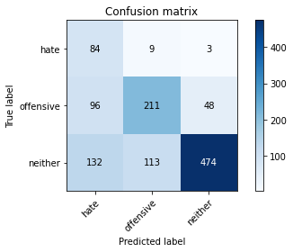

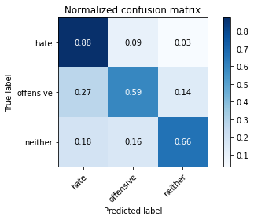

precision recall f1-score support

hate 0.27 0.88 0.41 96

offensive 0.63 0.59 0.61 355

neither 0.90 0.66 0.76 719

accuracy 0.66 1170

macro avg 0.60 0.71 0.60 1170

weighted avg 0.77 0.66 0.69 1170

average eval_loss: 1.417283437009585, accuracy: 0.6572649572649573

training 9 epoch...

16.508373260498047 seconds used......

9 training finished! average train loss: 0.06559191915273134

total clf loss: 1.3950357725843787 total adv loss: 1.1390558899729513

evaluating...

Confusion matrix, without normalization

[[ 73 19 4]

[ 78 250 27]

[111 186 422]]

Normalized confusion matrix

[[0.76041667 0.19791667 0.04166667]

[0.21971831 0.70422535 0.07605634]

[0.15438108 0.25869263 0.58692629]]

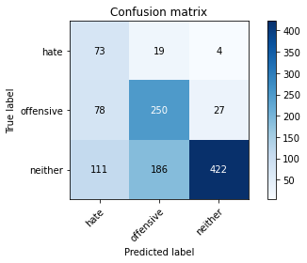

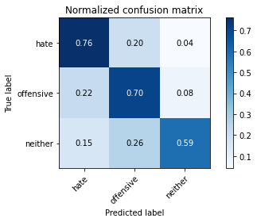

precision recall f1-score support

hate 0.28 0.76 0.41 96

offensive 0.55 0.70 0.62 355

neither 0.93 0.59 0.72 719

accuracy 0.64 1170

macro avg 0.59 0.68 0.58 1170

weighted avg 0.76 0.64 0.66 1170

average eval_loss: 1.6553339584399078, accuracy: 0.6367521367521367

training 10 epoch...

16.515960216522217 seconds used......

10 training finished! average train loss: 0.05028460659585627

total clf loss: 1.3108604615554214 total adv loss: 0.7525387414789293

evaluating...

Confusion matrix, without normalization

[[ 77 16 3]

[ 88 245 22]

[140 203 376]]

Normalized confusion matrix

[[0.80208333 0.16666667 0.03125 ]

[0.24788732 0.69014085 0.06197183]

[0.19471488 0.28233658 0.52294854]]

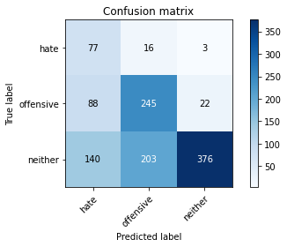

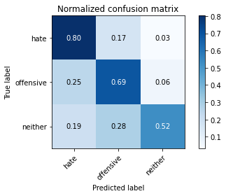

precision recall f1-score support

hate 0.25 0.80 0.38 96

offensive 0.53 0.69 0.60 355

neither 0.94 0.52 0.67 719

accuracy 0.60 1170

macro avg 0.57 0.67 0.55 1170

weighted avg 0.76 0.60 0.63 1170

average eval_loss: 1.8637786558118916, accuracy: 0.5965811965811966

5 run......

training 1 epoch...

16.477882862091064 seconds used......

1 training finished! average train loss: 2.271923120532717

total clf loss: 57.249516665935516 total adv loss: 34.989088982343674

evaluating...

Confusion matrix, without normalization

[[ 55 18 23]

[ 82 201 72]

[ 84 103 532]]

Normalized confusion matrix

[[0.57291667 0.1875 0.23958333]

[0.23098592 0.56619718 0.2028169 ]

[0.11682893 0.14325452 0.73991655]]

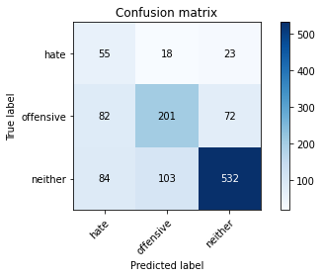

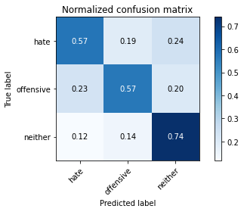

precision recall f1-score support

hate 0.25 0.57 0.35 96

offensive 0.62 0.57 0.59 355

neither 0.85 0.74 0.79 719

accuracy 0.67 1170

macro avg 0.57 0.63 0.58 1170

weighted avg 0.73 0.67 0.69 1170

average eval_loss: 0.8010440276840985, accuracy: 0.6735042735042736

training 2 epoch...

16.535927772521973 seconds used......

2 training finished! average train loss: 1.5919312526072775

total clf loss: 37.98641428351402 total adv loss: 25.58086797595024

evaluating...

Confusion matrix, without normalization

[[ 73 6 17]

[ 98 171 86]

[ 75 65 579]]

Normalized confusion matrix

[[0.76041667 0.0625 0.17708333]

[0.27605634 0.48169014 0.24225352]

[0.10431154 0.09040334 0.80528512]]

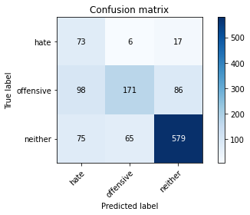

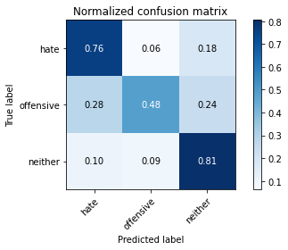

precision recall f1-score support

hate 0.30 0.76 0.43 96

offensive 0.71 0.48 0.57 355

neither 0.85 0.81 0.83 719

accuracy 0.70 1170

macro avg 0.62 0.68 0.61 1170

weighted avg 0.76 0.70 0.72 1170

average eval_loss: 0.6795534799664708, accuracy: 0.7034188034188035

training 3 epoch...

16.51493811607361 seconds used......

3 training finished! average train loss: 1.0155384348971503

total clf loss: 23.69830183684826 total adv loss: 16.585925310850143

evaluating...

Confusion matrix, without normalization

[[ 83 11 2]

[ 95 232 28]

[153 144 422]]

Normalized confusion matrix

[[0.86458333 0.11458333 0.02083333]

[0.26760563 0.65352113 0.07887324]

[0.21279555 0.20027816 0.58692629]]

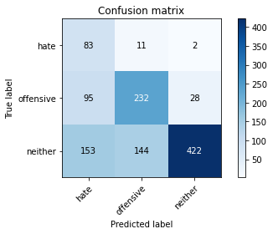

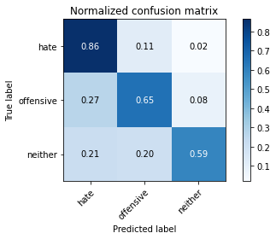

precision recall f1-score support

hate 0.25 0.86 0.39 96

offensive 0.60 0.65 0.63 355

neither 0.93 0.59 0.72 719

accuracy 0.63 1170

macro avg 0.59 0.70 0.58 1170

weighted avg 0.78 0.63 0.66 1170

average eval_loss: 1.0044736604569322, accuracy: 0.6299145299145299

training 4 epoch...

16.450262784957886 seconds used......

4 training finished! average train loss: 0.395740343523877

total clf loss: 10.896073207259178 total adv loss: 5.63269305229187

evaluating...

Confusion matrix, without normalization

[[ 67 18 11]

[ 70 231 54]

[ 79 106 534]]

Normalized confusion matrix

[[0.69791667 0.1875 0.11458333]

[0.1971831 0.65070423 0.15211268]

[0.10987483 0.14742698 0.74269819]]

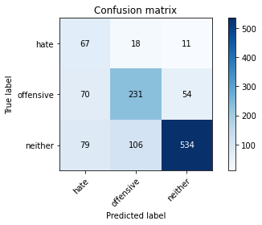

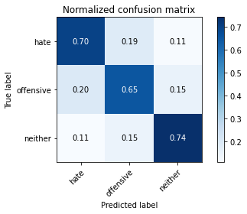

precision recall f1-score support

hate 0.31 0.70 0.43 96

offensive 0.65 0.65 0.65 355

neither 0.89 0.74 0.81 719

accuracy 0.71 1170

macro avg 0.62 0.70 0.63 1170

weighted avg 0.77 0.71 0.73 1170

average eval_loss: 0.7836258573047186, accuracy: 0.7111111111111111

training 5 epoch...

16.512718677520752 seconds used......

5 training finished! average train loss: 0.13706006231119058

total clf loss: 4.327204566448927 total adv loss: 1.6740794258075766

evaluating...

Confusion matrix, without normalization

[[ 79 11 6]

[ 80 225 50]

[ 92 113 514]]

Normalized confusion matrix

[[0.82291667 0.11458333 0.0625 ]

[0.22535211 0.63380282 0.14084507]

[0.12795549 0.15716273 0.71488178]]

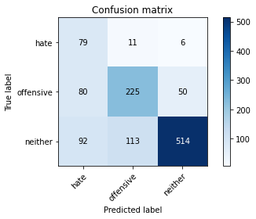

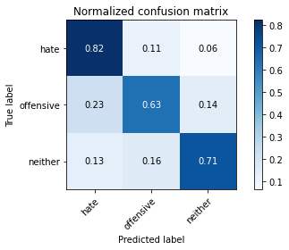

precision recall f1-score support

hate 0.31 0.82 0.46 96

offensive 0.64 0.63 0.64 355

neither 0.90 0.71 0.80 719

accuracy 0.70 1170

macro avg 0.62 0.72 0.63 1170

weighted avg 0.78 0.70 0.72 1170

average eval_loss: 0.9840860528461004, accuracy: 0.6991452991452991

training 6 epoch...

16.574544191360474 seconds used......

6 training finished! average train loss: 0.12986827337382628

total clf loss: 3.065242768265307 total adv loss: 2.1036903202766553

evaluating...

Confusion matrix, without normalization

[[ 75 15 6]

[ 66 247 42]

[ 74 137 508]]

Normalized confusion matrix

[[0.78125 0.15625 0.0625 ]

[0.18591549 0.69577465 0.11830986]

[0.10292072 0.19054242 0.70653686]]

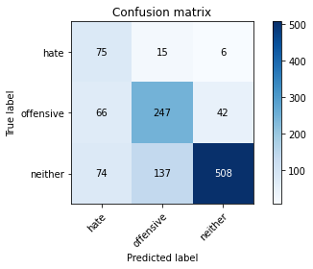

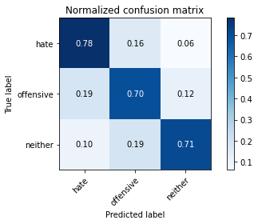

precision recall f1-score support

hate 0.35 0.78 0.48 96

offensive 0.62 0.70 0.66 355

neither 0.91 0.71 0.80 719

accuracy 0.71 1170

macro avg 0.63 0.73 0.64 1170

weighted avg 0.78 0.71 0.73 1170

average eval_loss: 1.0163590796923234, accuracy: 0.7094017094017094

training 7 epoch...

16.484500885009766 seconds used......

7 training finished! average train loss: 0.08804026798212103

total clf loss: 2.621647789143026 total adv loss: 1.1543036326766014

evaluating...

Confusion matrix, without normalization

[[ 85 9 2]

[ 82 239 34]

[125 138 456]]

Normalized confusion matrix

[[0.88541667 0.09375 0.02083333]

[0.23098592 0.67323944 0.09577465]

[0.17385257 0.19193324 0.63421419]]

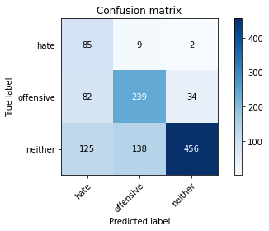

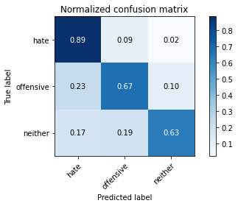

precision recall f1-score support

hate 0.29 0.89 0.44 96

offensive 0.62 0.67 0.65 355

neither 0.93 0.63 0.75 719

accuracy 0.67 1170

macro avg 0.61 0.73 0.61 1170

weighted avg 0.78 0.67 0.69 1170

average eval_loss: 1.2965657117508225, accuracy: 0.6666666666666666

training 8 epoch...

16.569397687911987 seconds used......

8 training finished! average train loss: 0.03939575169767652

total clf loss: 1.1167917686980218 total adv loss: 0.5446851619053632

evaluating...

Confusion matrix, without normalization

[[ 85 8 3]

[ 88 225 42]

[119 103 497]]

Normalized confusion matrix

[[0.88541667 0.08333333 0.03125 ]

[0.24788732 0.63380282 0.11830986]

[0.16550765 0.14325452 0.69123783]]

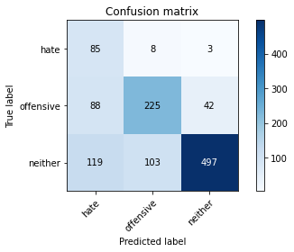

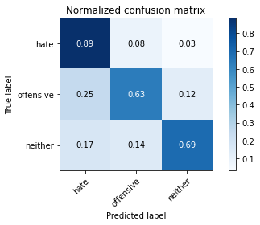

precision recall f1-score support

hate 0.29 0.89 0.44 96

offensive 0.67 0.63 0.65 355

neither 0.92 0.69 0.79 719

accuracy 0.69 1170

macro avg 0.63 0.74 0.63 1170

weighted avg 0.79 0.69 0.72 1170

average eval_loss: 1.3097633711867414, accuracy: 0.6897435897435897

training 9 epoch...

16.537481546401978 seconds used......

9 training finished! average train loss: 0.019013299735628868

total clf loss: 0.5545205852249637 total adv loss: 0.2551120938915119

evaluating...

Confusion matrix, without normalization

[[ 84 4 8]

[ 99 209 47]

[102 108 509]]

Normalized confusion matrix

[[0.875 0.04166667 0.08333333]

[0.27887324 0.58873239 0.13239437]

[0.1418637 0.15020862 0.70792768]]

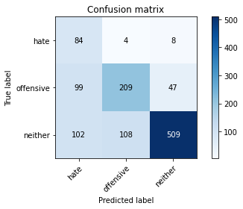

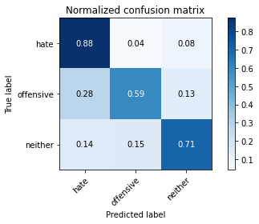

precision recall f1-score support

hate 0.29 0.88 0.44 96

offensive 0.65 0.59 0.62 355

neither 0.90 0.71 0.79 719

accuracy 0.69 1170

macro avg 0.62 0.72 0.62 1170

weighted avg 0.78 0.69 0.71 1170

average eval_loss: 1.4028225111759316, accuracy: 0.6854700854700855

training 10 epoch...

16.475672483444214 seconds used......

10 training finished! average train loss: 0.0128538042897292

total clf loss: 0.42603352398145944 total adv loss: 0.1468897505556015

evaluating...

Confusion matrix, without normalization

[[ 85 5 6]

[ 97 222 36]

[111 134 474]]

Normalized confusion matrix

[[0.88541667 0.05208333 0.0625 ]

[0.27323944 0.62535211 0.10140845]

[0.15438108 0.18636996 0.65924896]]

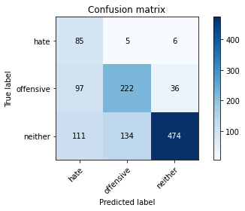

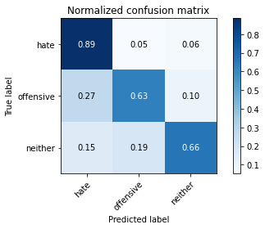

precision recall f1-score support

hate 0.29 0.89 0.44 96

offensive 0.61 0.63 0.62 355

neither 0.92 0.66 0.77 719

accuracy 0.67 1170

macro avg 0.61 0.72 0.61 1170

weighted avg 0.77 0.67 0.70 1170

average eval_loss: 1.5446655073408353, accuracy: 0.6675213675213675